**ECE 442 Lab 2**

**Ryan Brooks, ID: 1530605**

1. Looking at our dataset, we can see that we have a 2 dimensional data set (a system comprised of x and y coordinates). If we look at how the x and y coordinates change as we go along the data, we can see that it seems to increase linearly (for the most part) for both x and y and as such, we can safely assume that the best fit curve will be a straight line going up and to the right. Since we have made this assumption we can then say that the true dimensionality of the dataset is 1 dimensional.

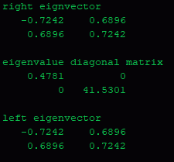

As we can see, the right and left eigenvectors are the same. The largest eigenvalue (V) is 41.53. This corresponds to the second column of both the left and right eigenvector (0.6896, 0.7242). There ia a relation between V and the spearhead of the datapoints. V is positive and the datapoints move up and to the right on the plane. This is also seen in the eigenvector which has 2 positive values,, indicating a move up the x and y axis in the positive direction.

1. Looking at the diagonal matrix below, we can see that the true dimensionality of the matrix is likely to be 3, this is because there are 3 eigenvalues that are larger and stand out more as compared to the others. We could likely prioritize the largest eigenvalue.

Note: the random matrix will be recalculated after every run of the program, leading to differences in what is shown below and what is seen in the read out of the program. My analysis was based on what is shown below.

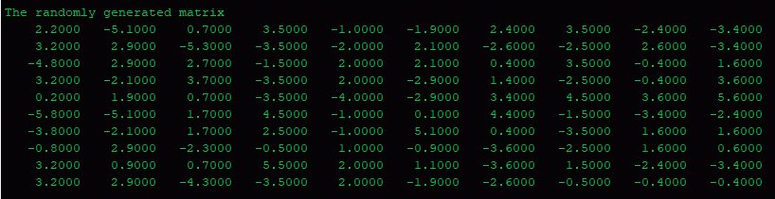

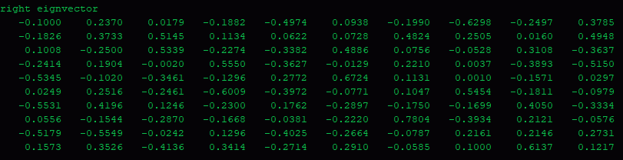

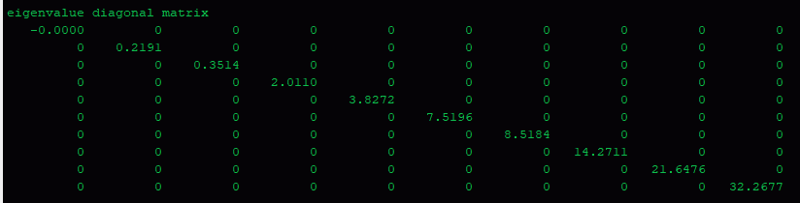

1. Below is the mean image

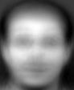

1. Please see Q5_1thEigen.bmp – Q5_5thEigen.bmp in the zip file
2. Please see Q6_1thEigen.bmp – Q6_5thEigen.bmp in the zip file

There seems to be some information in the images, but they do not resemble faces in the least. The images seem more like QR codes.

1. Below is a comparison of 2 of the images (the first is the image using PCA and the second is the image created from SVD. The main difference is that the images created with the SVD process are brighter than the images created using PCA. Please see the images in the zip file

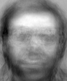

Figure : Q5_5thEigen



Figure : Q7_5thEigenSVD

1. Please see the attached images (Q9org.bmp and Q8rec.bmp) in the zip file
2. Please see Q9rec.bmp in the zip file.

The difference between Q8rec and Q9rec is that in Q9rec has more features and in particular, a smaller mouth than Q8rec. This is due to using more eigenfaces. I would either guess and test, depending on how many total eigenfaces there were, or look at a graph of all of the eigenfaces to determine which ones give the most information.

1. Please see attached Q10org.bmp and Q10rec.bmp. Note I used the top 50 eigenfaces for the reconstruction.